**Software Requirements**

**Specification**

**For**

**E-commerce website**

**Project Members:**

|  |  |
| --- | --- |
| **Name** | **ID** |
|  |  |
|  |  |
|  |  |
|  |  |
|  |  |

# Table of Contents

1. Introduction 1

1.1 Purpose 1

1.2 Intended Audience and Reading Suggestions 1

1.3 Product Scope 1

1.4 References 2

2. Overall Description 2

2.1 Product Perspective 2

2.2 Product Functions 2

2.3 User Classes and Characteristics 3

2.4 Operating Environment 3

2.5 Design and Implementation Constraints 3

2.6 User Documentation 6

3. External Interface Requirements 7

3.1 User Interfaces 7

3.2 Hardware Interfaces 7

3.3 Software Interfaces 7

4. System Features 7

4.1 System Feature 1 7

4.2 System Feature 2 7

5. Other Nonfunctional Requirements 8

5.1 Performance Requirements 8

5.2 Safety Requirements 8

5.3 Security Requirements 8

5.4 Business Rules 8

# Introduction

E-Commerce commonly Known as Electronic Marketing. It Consist of Buying and Selling Good. These business transactions can be done in four ways: Business to Business (B2B), Business to Customer (B2C), Customer to Customer (C2C), Customer to Business (C2B).

## 1.1 Purpose

The internet is no longer limited to searching information or connecting with people but is a platform where you can also buy and sell products. An ecommerce website is a website which allows your business to sell products and services to their online audience.

There are a variety of purposes that a website can serve, but most of them can be traced back to one common goal: generating a profit. Some of them do this more subtly, choosing to highlight the quality of a craft or to showcase one’s expertise in a particular field. Others, namely the ecommerce site, act as a virtual store in which visitors become customers walking down the digital aisles of your business, filling up their carts with your products.

## 1.2 Intended Audience and Reading Suggestions

## Online shopping is mainly used by older people who are working as they have a credit card from which they can pay for their goods. They use it because they come back late from work and so shopping is very tiring, consequently they turn to online shopping where their items are delivered to them. But now-a-days mostly not only older but also younger people use this.

The document is intended for, such as developers, project managers, marketing staff, users, testers, and documentation writers.

## 1.3 Product Scope

Scope of E-Commerce is immense. But currently there are many competitors in the market which are not only for the shopping of electronic things or clothes or such but now many platforms have come up with the Services like online selling of Furniture, Groceries etc. So To survive in market one has to have many research to know the market deeply.

**1.4 References**

* Costello, Daniel "I Know You: Getting Closer to Your Customers" eCRM, Volume 2, Issue 12 (pgs.4-7) December 1999
* Englier, Natalie, "Global e-commerce" Informationweek, Issue 755 (pgs.88-94)October 4, 1999
* Feldman, Susan, "Advances in Digital Libraries . 97" Information Today, Volume 14, Issue 7 (pgs.12-16) Jul/Aug 1997
* Flister, Erik, "Intuitive Software" Research & Development, Volume 41, Issue 7 (pgs.66-69) June 1999
* Fernandes, Tony "Global User Interface Design" Communications of the ACM. May 7-11 1995
* Lohse, Gerald L., Spiller, Peter, "Electronic Shopping", Communications of the ACM, Volume 41, Issue 7 (pgs.81-87) July 1998

# 2. Overall Description

## 2.1 Product Perspective

The perspective of this project is to develop a site that is very easy to use and user friendly. One of the major perspective behind the creation of ecommerce is none other than cost saving. Unlike a brick and mortar store, you do not need to buy or rent a place for opening your store. Similarly, in a virtual store unlike a brick and mortar store you also do not need to hire employees, look after them, manage them and pay them.

## 2.2 Product Functions

* Menu
* Catalog

1. Brand

2. Category

3. Product List

* Shopping Cart
* Registration Or Login
* Checkout
* Payment Method
* Home Delivery By Delivery Man

## 2.3 User Classes and Characteristics

## At any places where there is an internet connection can use this e-commerce site and can able to shop online by using this site.

## 2.4 Operating Environment

## Arduino boards can be programmed easily using the Integrated Development Environment (IDE). This environment is for writing programs that can be loaded on the board. Arduino is found in several variants depending on the sizes and capabilities. The board used for this work is Arduino Uno*.*

## 2.5 Design and Implementation Constraints

Languages:

* *HTML/HTML5*
* *CSS/CSS3*
* *Bootstrap*
* PHP(Laravel)

Tools:

* Sublime Text
* Xampp
* Composer
* Browser(Mozilla, Chrome)
* Laravel Packages

Overall System Design:

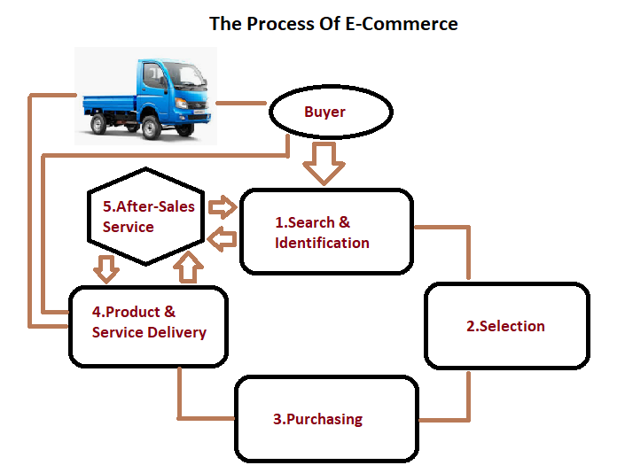

Data flow model:

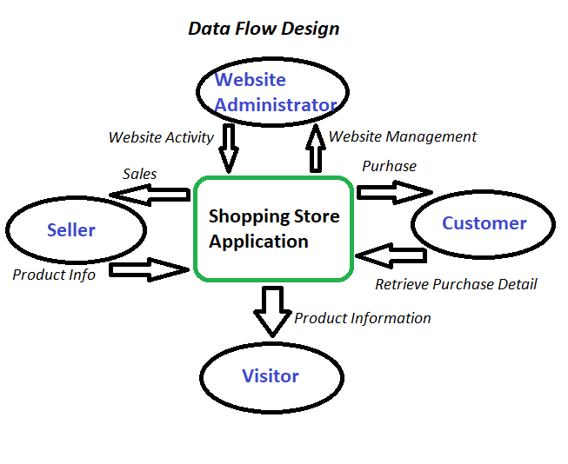

Business process model:

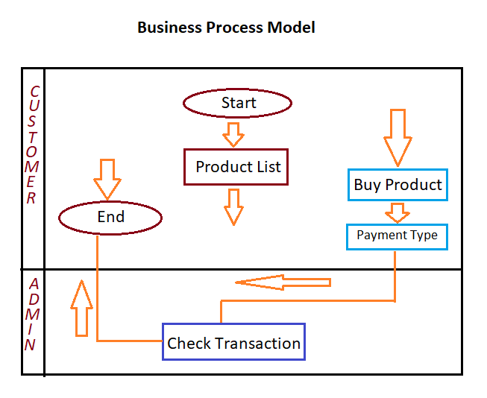

## 2.6 User Documentation

To use this online e-commerce site, these steps are need to know

* First user have to complete registration.
* Then he/she can able to log in by using username and password.
* Then there is a search key to find the desire product.
* After that if anyone want buy something it will go in cart.
* After confirmation of the desire product, they will have to complete the payment.
* Then they will get the product through home delivery.

# 3. External Interface Requirements

## 3.1 User Interfaces

User Interface (UI) is the visual part of this e-commerce site that determines how a user interacts with an application or a website and how information is displayed on the screen.

## 3.2 Database Interfaces

In our database part we collect all the data of the user in our data server.

## 3.3 Software Interfaces

## We have done installing xampp to use php. It is easy for developers to create a local web server for testing and deployment purposes. We Sublime Text is a proprietary cross-platform source code editor where functions can be added by users with plugins, typically community-built and maintained under free-software licenses and uses laravel packages.

# 4. System Features

## 4.1 System Feature 1: People Can Buy Product Online

E-Commerce has become a way of life and website owners that satisfy the requirements of the online shopper are fattening their wallets. By using this people can able to order anything while staying at home.

**4.2 System Feature 2**: Easy payment method

Our project payment method is so simple that it is very easy for a new user to buy something and complete the payment method.

# 5. Other Nonfunctional Requirements

## 5.1 Performance Requirements

This site can use from anywhere there is an internet connection from any mobile devices and computer, laptop or any internet platform.

## 5.2 Safety Requirements

We’ll never store any customer sensitive data. We’ll have a Better Ecommerce Hosting Service. We’ll ensure that we backup our ecommerce website frequently.

## 5.3 Software Quality Attributes

We have done a very little project. But we’re working on it to make it professionally.

## 5.4 Business Rules

We do not launch our product in the market yet. But when we release this product in the market, we ensure that the service of this product can satisfy the people and we can able to ensure the security of the user.